# Venice, Chioggia, Mantova, and the Whitworths!!

What a great week! A busy week, but a great week. So many things to share!! Most importantly, Abby, Gwen and Amber are in Italy now. This will be the best month ever!

L to R: Scott, Gwen, Me, and Abby :)

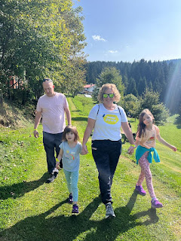

Warning: This will be a lengthy blog, with LOTS of photos. Prepare yourself. :)

Monday, Sept. 25th:

I rode the train to Venice with our friends, Scott and Jen Anderson (from Idaho Falls). We weren't sure if things would be open on a Monday, because Italy tends to close a lot of things on Mondays. But, after some online research, we felt good about things still being open in Venice, so off we went.

Walking into the Vicenza train station, after Scott dropped us off on his way to work.

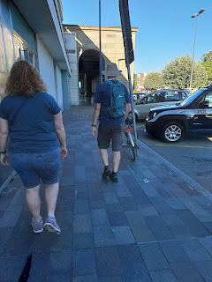

The train was crowded as expected, but eventually we were able to claim a seat for the last half of the 49 minute ride to Venice. The Santa Lucia Stazione (station) is right on the Grand Canal of Venice, with the largest boats and merchants crowding the waterway, but in somewhat of an organized chaos.

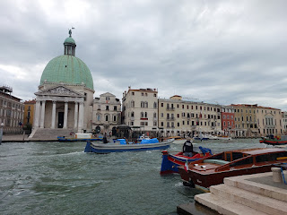

We didn't have much of a plan for the day, other than to get to the Rialto Bridge, and eventually to St. Mark's Square. It was enjoyable to just wander and see what we could see along the way.

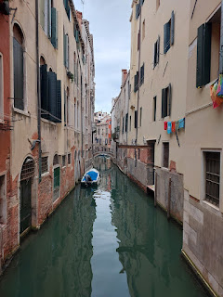

There is 1) Mainland Venice and 2) Lagoon Venice. The train takes you all the way out to the lagoon, which is fantastic. Venice (in the lagoon) is shaped like a giant fish, with lots of canals that separate it out into roughly 118 small islands.

In the map below: (click to enlarge photo)

Santa Lucia Train Station (circled in blue)

Rialto Bridge (circled in red)

St. Mark's Square (circled in purple)

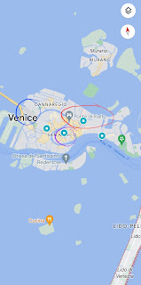

When Jake and Hannah came to visit us in May, we walked around almost the entire fish-shaped Venice in 6 hours. The only area we didn't explore was the lower left portion, where the mouth of the fish would be. This time, with the Andersons, we walked a more direct route to these two areas (Rialto Bridge & St. Mark's) and then back to the train station.

So what else did we do in our 5 hours that day?

We browsed . . .

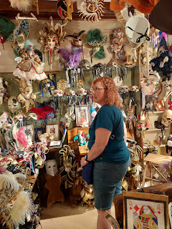

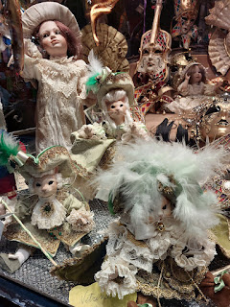

Jen, Scott A. and me, with the Rialto Bridge in the background . . .

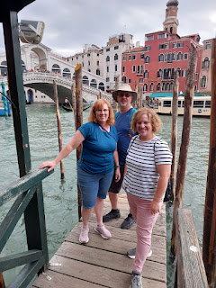

We drooled over these glorious canolis in the storefront window . . .

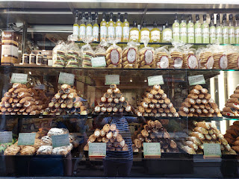

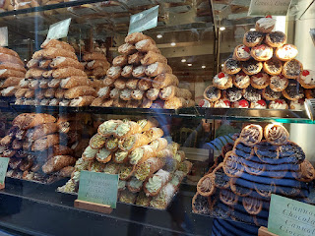

We did purchase an apple strudel pastry in one of the little shops later on, and it was amazing.

We took photos of the gondoliers and their passengers . . .

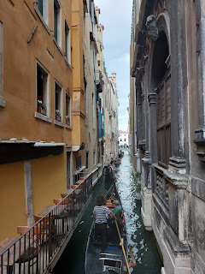

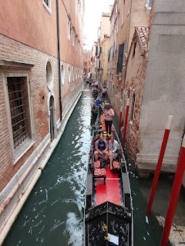

We admired the extraordinary patience this lady must have had, to slowly and carefully vacuum in between every single tiny little item on the shelves of their front window . . .

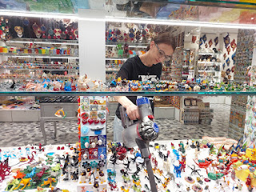

As we made it to St. Mark's Square (Piazza San Marco), the clouds were beginning to dissipate, allowing us to see some beautiful blue sky, but also allowing the heat of the sun to penetrate through, too.

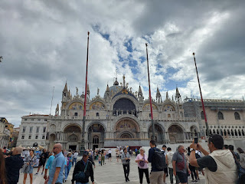

Video of the mini orchestra that rotates around the square: (35 seconds)

https://photos.app.goo.gl/mHXRfRc7FfsaEWi57

In the half-dozen or so times that I've been to Venice, there is always a very long line of people waiting to get into the Doge Palace and Basilica. We've either been too pressed for time to get into that long line, or there is someone in our group who does not have the patience to stand and wait. So even though I have always wanted to go in, I've never actually been inside. Until this day.

Jen and Scott suggested that we at least get in the line and try, with the idea that "let's just see how long it takes us to move forward to the corner of the building up there . . ." With their patience and willingness to see it through, we did it! It took about 45 minutes to get from the back of the line to the entrance, which went by pretty fast. And it was only 3 euros to enter!

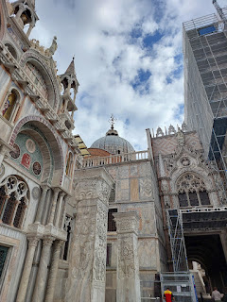

I was feeling a few butterflies in my heart as we walked through the doors, because I knew that my ancestors had been here over 500 years ago, too.

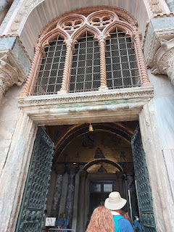

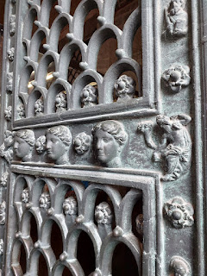

To stand where they once stood . . . wow. What an incredible experience.

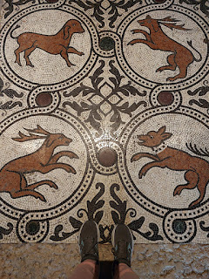

On my mom's side of the family, the Normans married the Sikes. The Sikes married the Laniers further back. And the Laniers married the Italian Bassanos even further back.

My 13th great grandfather was Nicholas Lanier (I believe that because he was French, it would have been pronounced more like "lan-yer" or "la-nyey"). He married Lucretia (or Lucreece) Bassano. The Bassanos were musicians, both in playing the instruments and also in making them.

Jeronimo Bassano

was Lucretia Bassano's grandfather, and my 15th great grandfather. He was born in approximately 1481 in or near Bassano del Grappa. Here is a little blurb from Wikipedia:

"Jeronimo Bassano

was an Italian musician in the

Republic of Venice

who is notable as the patriarch of a family of musicians: five of his sons,

Anthony

, Alvise, Jasper, John (Giovanni), and Baptista Bassano, moved from

Venice

to England to serve in the court of King

Henry VIII

. They performed as a recorder consort.

"Jacomo Bassano was his only son to keep his primary residence in Venice. Jeronimo Bassano never moved, and he was listed in Venice as a "Maestro of the

trumpets

and

shawms

." He is believed to be the maternal grandfather of composer

Giovanni Bassano

.

[1]

"Jeronimo was the son of Baptista "Piva" of

Bassano del Grappa

, a town 35 miles from Venice. Baptista was a musician who played the

piva

, a small bagpipe. He was the son of Andrea de Crespano, who was from the village of Crespano, about nine miles east of Bassano. Andrea, Baptista, and Jeronimo were all described as musicians and musical instrument makers.

[2]

"

At the beginning of the 16th century, Jeronimo moved from Bassano to Venice, where he was described as "Maestro Hieronimo", a

piffero

player to the

Doge of Venice

between 1506 and 1512.

"

The Bassanos were famous for many generations as they performed for royalty and in many other notable settings.  Jeronimo's son, Anthony, was Lucretia's father, and my 14th great grandfather. And let me also add, that Doge means "Duke" or "chief magistrate". It is pronounced like "dozh", or like the last part of the word "garage". (I have been accidentally pronouncing it "doh-jee" this whole time . . . )

Back to our tour . . .

I tried to capture different elements of the Palace and Basilica, with a variety of textures and aesthetics, because I don't know to what extent I'll be able to go inside again. It just depends on who I'm with and what the circumstances allow for.

All of the gold that you see in the photos below are made up of tiny little gold mosaic tiles. Unbelievable.

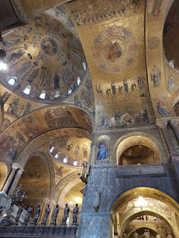

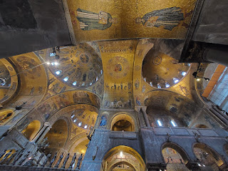

If you want to pay a little extra, you can go inside this little nook area to see the Pala D'Oro, the altar retable, made of precious goldsmith's gold and other precious stones and pearls from the 10th-12th centuries. (You can read more by clicking on the photo below to enlarge it.)

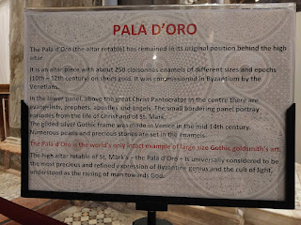

I chose to just take a photo from the corner where I stood . . . rather than pay extra.

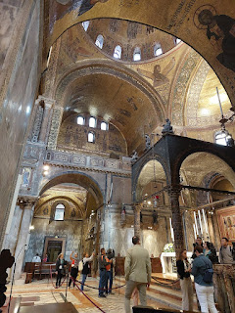

And another photo from the front view of the altar . . .

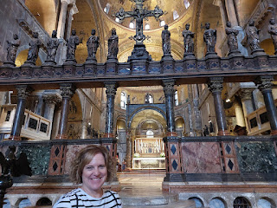

The mosaic tiles on the floor were masterful, and you had to remember to look down almost as often as you look up.

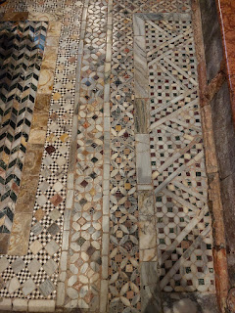

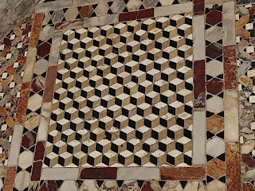

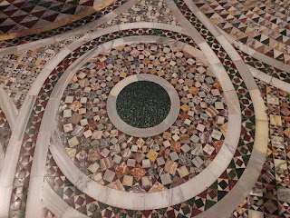

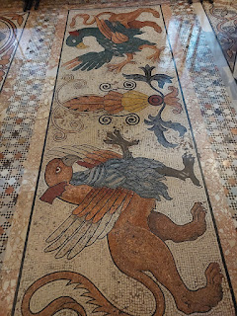

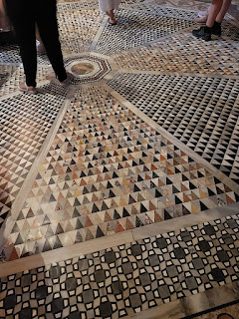

We continued our very slow walk through the Basilica. One thing to note, is that we thought we would be touring the Palace, but most of that was roped off, so we mainly ended up just touring the Basilica, which was attached to the Palace.

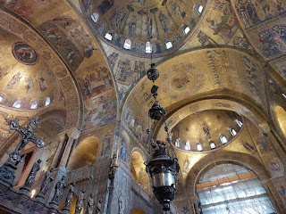

High above our heads . . . mosaics out of gold tiles were everywhere . . .

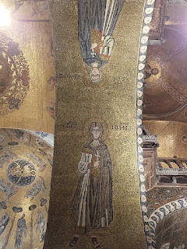

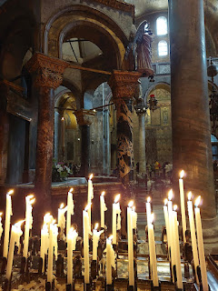

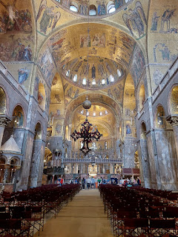

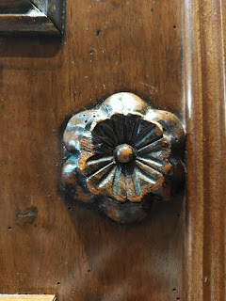

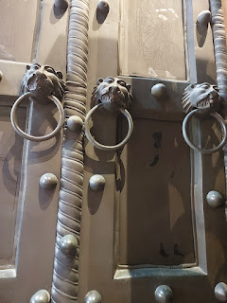

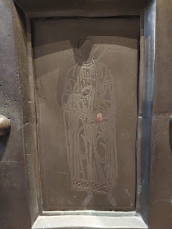

We paid an additional 7 euros to go upstairs to see more rooms and relics . . .

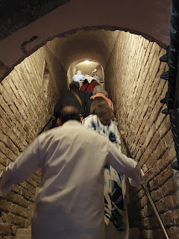

That's when we could see and touch some of those tiny little gold tiles up close . . .

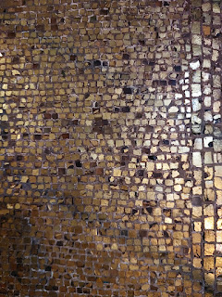

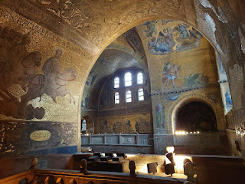

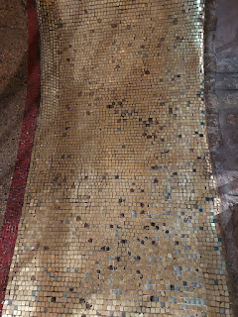

Upstairs, it was sort of a museum with art that had been uncovered, discovered, and recovered in some form or another over the years. I will share a few of my favorites here, but I will also include a link to the entire photo album from the Doge Palace, if you have more time and want to see more.

Link to photo album:

https://photos.app.goo.gl/sddgya5BkNGWENR26

John the Baptist, as he receives the "vestments from the angel" . . . (14th century mosaic)

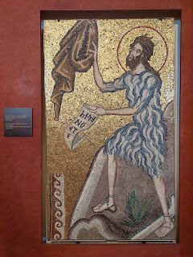

I loved this next one, but couldn't find any signage regarding it. It appears to be the infant Jesus, with the halo around his head. So it might be his earthly father, Joseph, holding him on his shoulder.

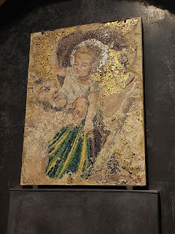

Little doors are always so curious and cute to me.

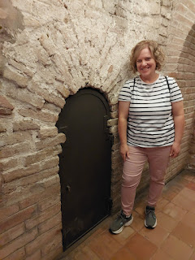

When I stepped into this next room and saw the description of what I was looking at, my eyes instantly filled with tears and it literally took my breath away . . .

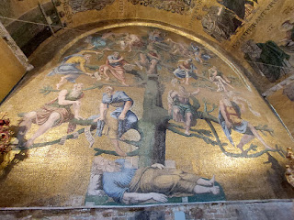

Mary, the mother of Jesus, and her family tree!!!

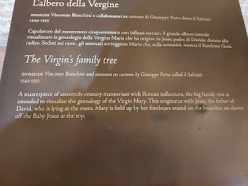

This was a very powerful moment for me to experience. I love family history so much, and yet I had never considered Mary's family tree, and therefore Jesus' earthly family tree. Wow. What an incredible thing for an artist to create! And I love the use of the phrase, "Mary is HELD UP by her forebears . . .", as described in the photo above. It's so true!!

This was the most joyful thing I saw during the entire day, hands down.

Other notable items included these beautiful old tapestries, depicting several scenes leading up to the Crucifixion of Jesus Christ and His subsequent Resurrection. Ten in all, they were woven from wool in the 15th century.

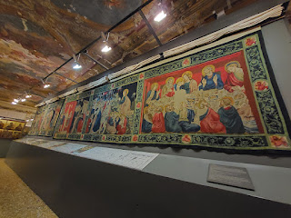

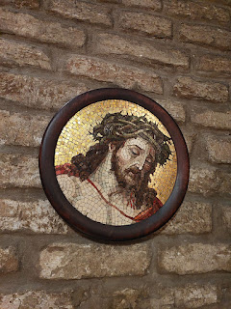

15th and 16th century choral books, used by the Roman-Franciscan monks as part of their chants.

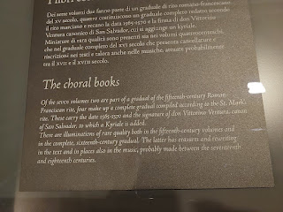

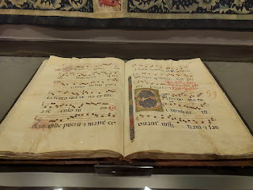

A 15th century wooden crucifix . . .

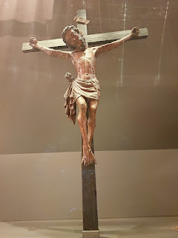

8th century marble fragment . . .

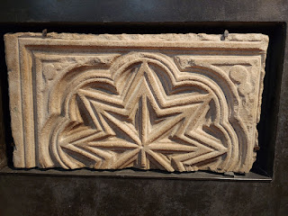

St. Mark's Horses . . . (more about that below)

Approx. 2nd century AD

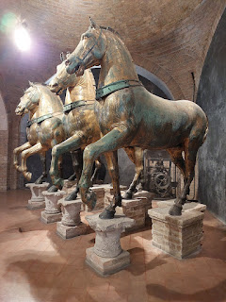

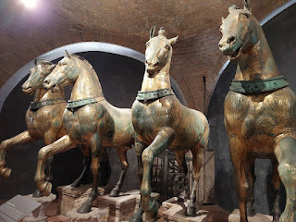

Click on the photo below to read about the history of these horses and how they were made.

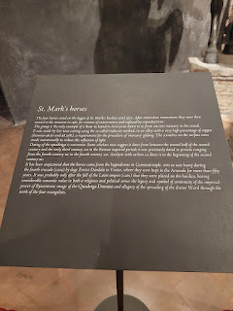

Paying that extra 7 euros also allowed us to go out onto the balconies, which was so nice.  This is the view overlooking St. Mark's Square.

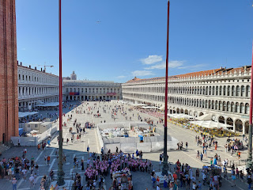

Another view from the balcony, looking south to the Sea.

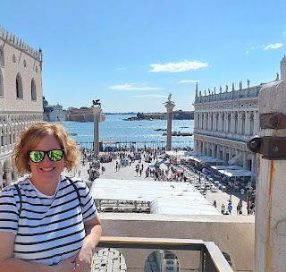

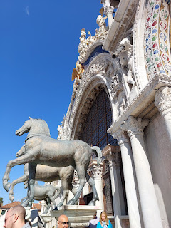

A smaller version of the Basilica . . .

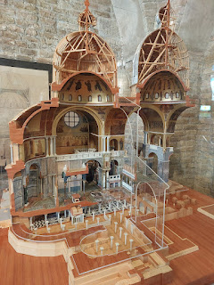

Jen and I really loved admiring the window panes. They were made up of several small circular pieces of glass, arranged in multiple squares. It was really quite lovely.

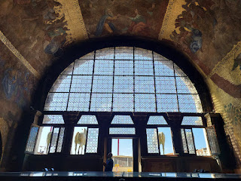

That concluded our tour of the Basilica and Doge Palace. Our heads were spinning and our tummies were growling at this point, ha ha. We walked briefly out to the water's edge so they could see the beauty of the marina area, before we went in search of food.

There are so many beautiful people walking around Venice, many of them just naturally wanting to look good, but many with plans for a few strategic photo ops as well.

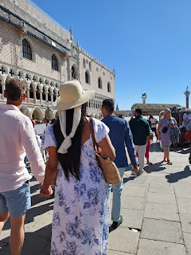

Looking south from the Doge Palace and harbor . . .

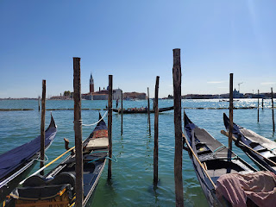

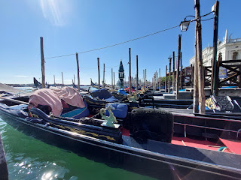

After taking note of the time and realizing we didn't have much time to start making our way back to the train station, we began walking in that direction and keeping our eyes peeled for a lunch spot along the way.

Success! Pizza and calzones . . . yum!

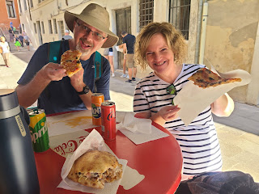

We made it all the way home and made ourselves a nice dinner later that evening: Salmon, spinach, sweet potatoes, and bread to dip into a variety of olive oils and vinegars.

L to R: Scott A., Scott H., Me, and Jen

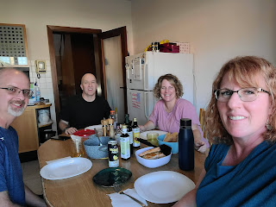

After dinner, we hopped on the bus to go walk around downtown for a little bit. We ran into our good friend, Nell Zeitzman, who joined our evening stroll. She was a wealth of knowledge and filled in a lot of background info for us, as to what we were seeing. She even took us over to the San Michele Bridge of Vicenza, which was just a short walk from the main Piazza. First, we walked across it, and then she brought us around the block so we could see the beautiful bridge from afar, along with its reflection in the canal below. How lovely.

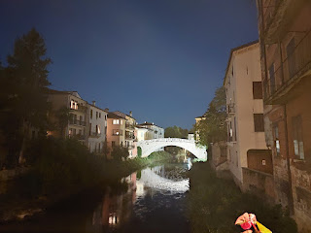

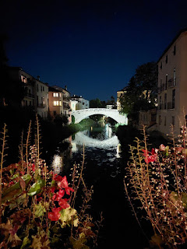

Tuesday, Sept. 26th:

I drove us to Chioggia, just over an hour's drive southeast of Vicenza. Known as "Little Venice", I wanted to show them a slower pace of life after spending time in Venice the day before.

We basically did a repeat of what Scott and I did last Saturday in Chioggia: Go on a boat tour, visit the Ponte Vigo Bridge, walk around, and find some lunch before heading to Sottomarina and hitting the beach. The one thing we added that was new this time was visiting the fish market, which was lively and fun.

On a quiet Monday morning, there were only about 6 of us tourists that wanted the boat tour at 10:00 a.m., so they put us on their smaller boat, which was still fun.

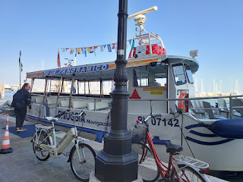

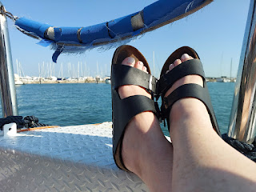

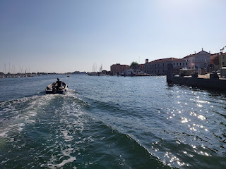

Video of a fisherman heading out to sea in his wetsuit, passing us by: (16 seconds)

https://photos.app.goo.gl/ytDcv6BVHeE8nMSJ6

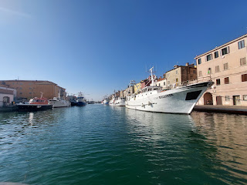

Video of some of the fishermen on their boats, preparing to head out: (25 seconds)

https://photos.app.goo.gl/wJGAp6GF4oU8nLL46

It was sunny and warm and gorgeous at 10 a.m. If anyone needs some stress relief, this is your place. Come on over and I'll take you to Chioggia. (kee-YOH-ja)

After the cruise, it was time for some pictures on the Ponte Vigo Bridge . . .

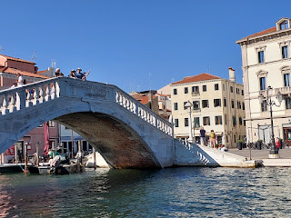

We walked down the east side of the canal for a long ways, and I got to see a few new things.

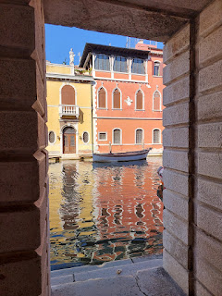

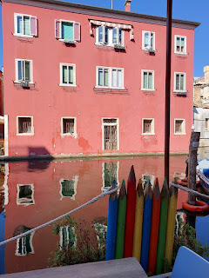

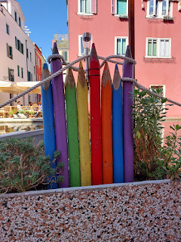

Across the canal, with the red awning, is the fish market.

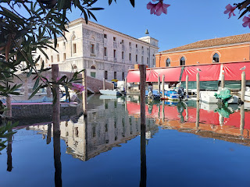

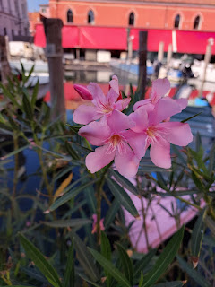

Scott and Jen, at the entrance of the Box 22 Fish Market of Chioggia . . .

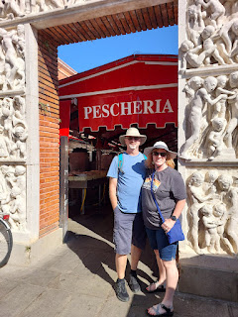

Video #1 inside the fish market: (16 seconds)

https://photos.app.goo.gl/rjVVbnVTyTHJsKXj6

Video #2 inside the fish market: (31 seconds)

https://photos.app.goo.gl/dj822gC85z95Tqmp6

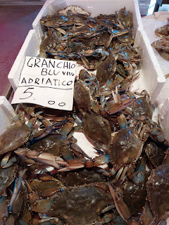

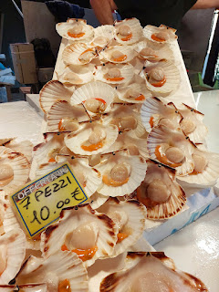

Next time I come to the fish market, I plan to bring my new insulated lunch box with a few gel-filled freezer bricks to keep the items fresh until I get home. I love seafood so much, and I need to learn how to work with it and make meals out of some of the exotic fish varieties. Not so much of the eel though . . . no thanks.

We found a great place for lunch on the main street, Corso del Popolo. It was called, Al Ciketo. (Al chee-KETT-toh) The prices were very reasonable and they had some nice seafood options.

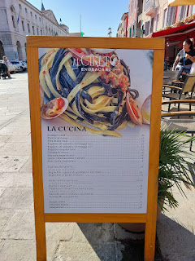

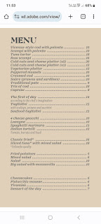

I ordered the regional dish of Baccala alla Vicentino, my third time of trying it. It translates as Vicenza-style cod with polenta. This time, though, the cod was pretty skimpy compared to the exorbitant amount of polenta, ha ha. At least I've tried it this many times, and in totally different areas of the region.

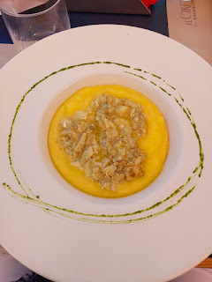

Buon Appetito!

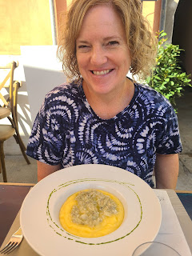

Scott A. ordered the mixed fried fish, which included tempura-battered tiny sardines/prawns/calamari and also tempura-battered zucchini and carrot sticks.

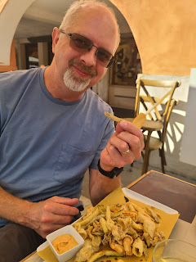

Jen ordered a dish of black and white long pasta noodles mixed with mussels and clams. We think the black noodles were made by incorporating black squid ink or something similar. She said it was delicious!

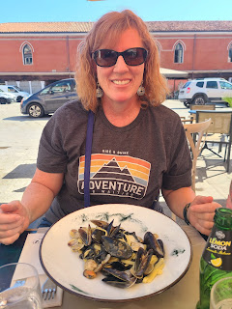

I was glad I also ordered a big bowl of mussels (just 10 euros), since I didn't get much protein on top of my overly abundant polenta. I left a lot of polenta behind, and that's okay. The mussels were messy, but amazing!! Thankfully, they give you a wet wipe to clean up with afterwards.

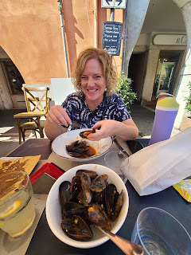

After lunch, we drove over to Sottomarina, adjacent to Chioggia and connected by a bridge. We went to the same beach where Scott and I went last Saturday, at the northern tip of the island.

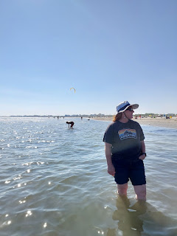

There were several kite surfers and para-sailers out on the water, probably because it was a much breezier day than it was on Saturday.

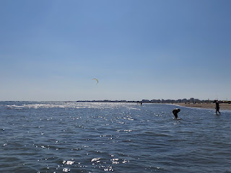

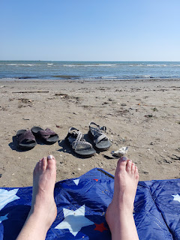

A lady was slowly wading in the water close to the beach, bending over occasionally to pick something up that was white in color. I went out to investigate, and found that there were several white clams right there in the shallows. I also found a larger shell to bring home.

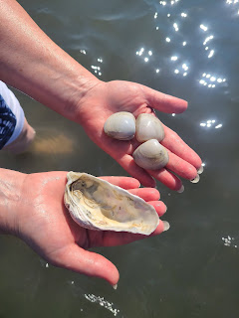

I gently sloshed my way over to the lady, who looked incredibly tan for someone her age (maybe 60s?), so that I could ask her if she wanted the 3 clams that I found. She was very grateful as she accepted my little gift. She added them to her bag on the beach, which was quite full already. (maybe a gallon of clams or so)

I asked her in my limited Italian if these were "per la cocina", which means "for the kitchen". (la cocina = la koh-CHEE-nah) She said, yes, and that they were delicious over spaghetti!! How fun.

All too soon, it was time to leave the beach and start the drive home. We were in a little bit of a time crunch because I wanted to take Jen and Scott to see one more thing before they left in the morning, and the last showing was at 4:30 p.m. in Vicenza.

We got home with just enough minutes to freshen up, hang up some laundry to dry, and drive across town with my Scott, after he got home from work. He dropped us off at the Olympic Theater (Teatro Olimpico) while he looked for a place to park. As we bought our tickets, we learned that my Scott could get in for free with his military ID card. It's only for the service member, and not for any other family members, but that's okay. It was just 9 euros (each) for the rest of us.

The Olympic Theater was built in 1580 by Andrea Palladio. He designed it and then it ended up being his last great work. He died before it was completed, so another architect finished up what Palladio began.

It is the oldest continuously used stage set in the world.

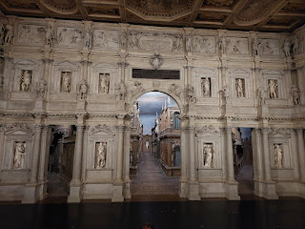

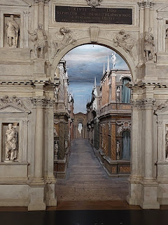

I first toured the Olympic Theater last November, as part of my Benvenuti Class (Welcome to Italy), meant for spouses and family members of the soldier that has been assigned to Vicenza. I will provide a link to the blog post from November 2022, since it provides greater details about the theater, and also so I don't just repeat things that I've already shared. :)

https://micheleharmon13.blogspot.com/2022/11/ancient-padova-vicenza-tours.html

The reason why I wanted to squeeze in this special tour with the Andersons is because they are HUGELY into theater and musicals as a family. They often audition with their kids for local productions, and their daughter is now a drama teacher for a local high school. Scott A. even recently designed and crafted a large stage set for the high school's Little Theater.

They marveled in awe to see the theater in person before they left Vicenza. We had the pleasure of seeing the 10-minute lights and sound show together, which showcases all of their lighting combinations and capabilities throughout the massive theater. Very impressive.

For dinner, we ordered through GLOVO, the European version of Door Dash. The young adults that do all the deliveries typically travel by E-bike or electric scooters so they can zip around town faster. We ordered from a Kebab place across town, and it arrived in about 30 minutes. We ate upstairs on the roof and then played card games up there until bedtime.

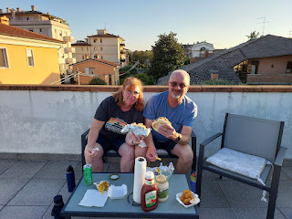

They were wonderful guests, always wanting to pitch in with meal prep and then always washing the dishes afterwards. They insisted on buying my tickets to the Doge Palace and buying any meals that we ate away from the house. Very generous friends. :)

Wednesday, Sept. 27th:

Scott drove them to the train station at 7:00 a.m. so they could make it over to Cinque Terre by lunchtime. Their friends from Boise were already there, and now they will all travel together for the rest of their Italian tour. They will be seeing Sorrento (way down south), the island of Capri, Naples, and Rome, before they fly back to the States. They began their trip in Amsterdam for a few days before they flew into Venice and spent some time with us here. Scott A. served his mission in Amsterdam many years ago, so he was happy to go back for a visit.

While they headed off to Cinque Terre on the train, I got ready for a field trip with my "Wednesdays in Italy" ladies group. We went to a new place where none of us has ever been before: Mantova. On a map, it is seen as either Mantua or Mantova, sort of like the nearby city of Padova (also seen as Padua).

Mantova is roughly 1 hour SW of Vicenza. It has a long history, dating back to approximately 2,000 BC. For the history buffs out there, check it out on Wikipedia:

https://en.wikipedia.org/wiki/Mantua

Our purpose in coming to Mantua/Mantova was to visit the Palazzo Ducale, or Duke's Palace. It is situated next to 3 man-made lakes, which are quite large. You can see the massive Palace in the photo below. (click photo to enlarge)

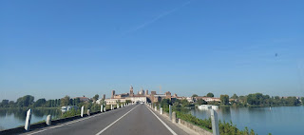

Sorry for the glare on this plaque, but it has some really interesting information. It says that the Palace is made up of several buildings, that, together, form 1,000 rooms and has a span of approximately one square mile.

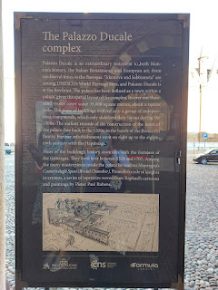

On our way to the entrance of the Palace, after buying our tickets . . .

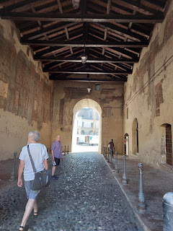

It was immediately apparent that our tour of the Palace would primarily consist of art and culture, mostly from the Renaissance era. It was all very beautiful and, at times, breathtaking.

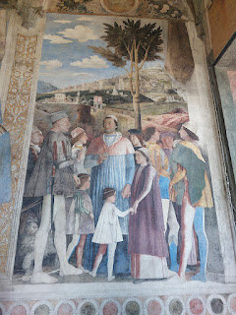

Video of the first main room we saw: (16 seconds)

https://photos.app.goo.gl/bhMeKnxXMYCreYUG9

An explanation of the large mural: (click photo to enlarge)

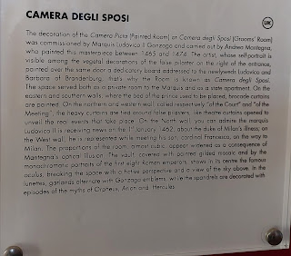

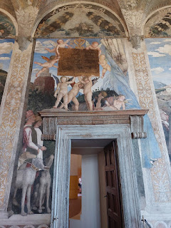

I was drawn to these early 16th century shoes on display in another room. Somebody's ancestors wore these shoes, and I'm sure there are some fascinating stories they could tell.

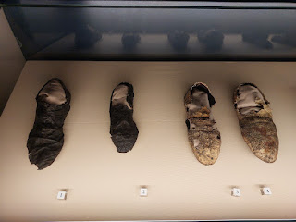

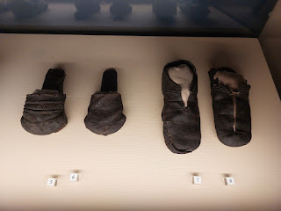

An explanation of the shoes. (click photo to enlarge)

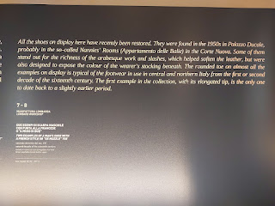

Several courtyards during the tour, including an exciting one coming up in a minute . . .

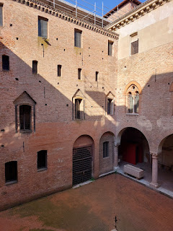

Every hallway, every room, every alcove was just exquisite.

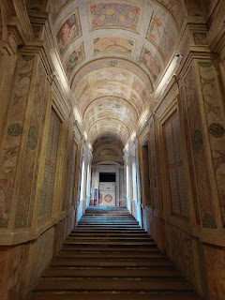

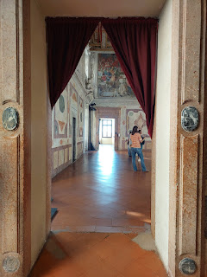

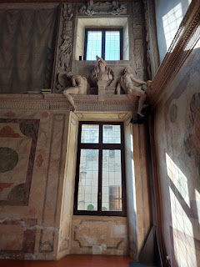

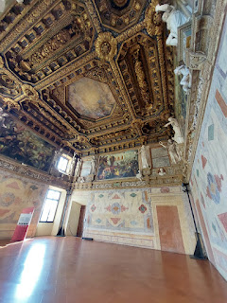

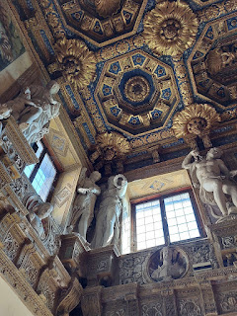

The Statue Museum within the Palace consisted of mainly Greek and Roman artifacts. These were a couple of my favorites because they each depicted a tender scene.

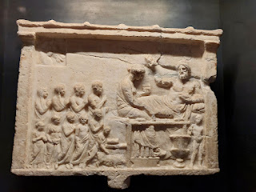

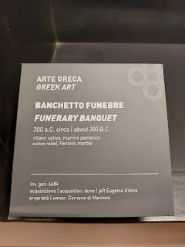

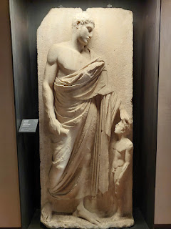

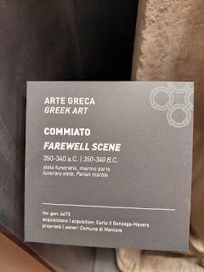

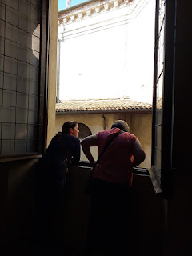

This expansive mural on the ceiling of one room tells the story of the Fall of Troy. (1184 BC)

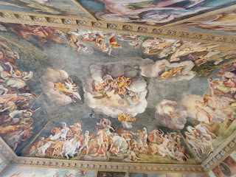

Hopefully, if you click on this "map" of the mural, you can enlarge the words enough to read the explanation.

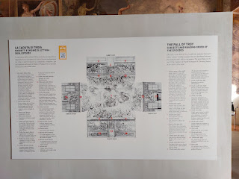

Short video of the Gallery of the Months: (17 seconds)

https://photos.app.goo.gl/cxznTnhUbiC958Rd9

This is where we learned that in the courtyard below, a British film crew was preparing the set for a scene in an upcoming movie.  Several of us had our noses pressed up against the Palace windows to watch them and/or record what they were doing, ha ha.

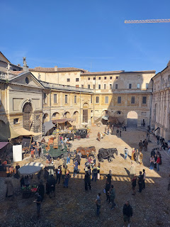

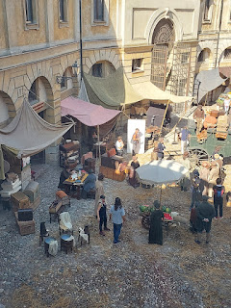

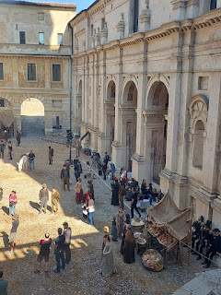

Video of the film set: (34 seconds)

https://photos.app.goo.gl/XBVdxz8EouAdpLsx6

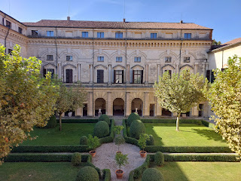

A portrait of one of the Gonzaga ladies with her pet doggy . . . (1582)

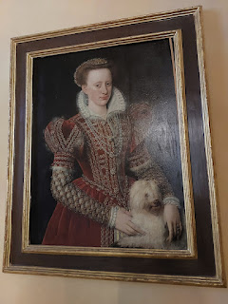

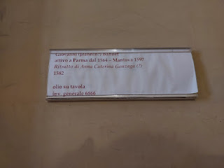

One of the royal bedrooms . . .

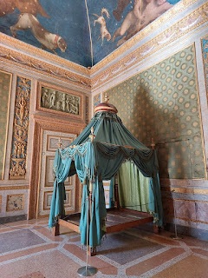

I don't know about you, but I'm not sure I could sleep very well with lions, snakes, and menacing creatures staring down at me from the ceiling . . .

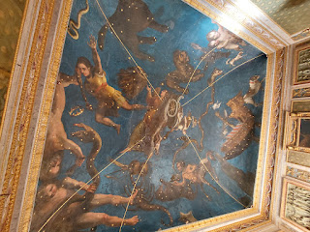

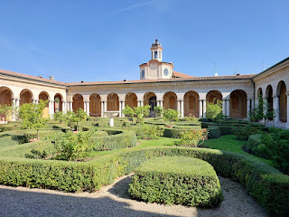

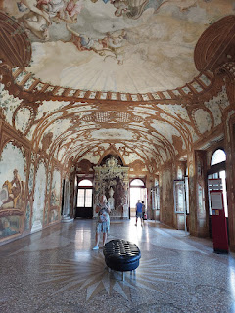

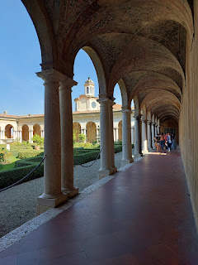

The Apartment of the Empress, created in 1778 for Beatrice, the wife of Ferdinando of Austria . . .

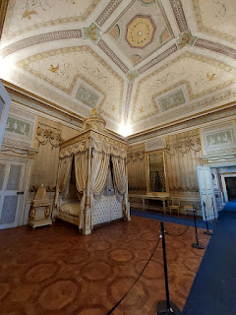

Katie, Addie Mae, and I stayed behind the rest of the group so we could take our time absorbing and identifying the many scenes of Jesus that were sewn onto ancient tapestries . . .

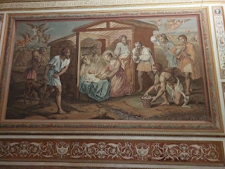

In this scene, Jesus is depicted as a literal Gardener when He appeared to Mary Magdalene after His Resurrection, and when she mistook Him for one . . .

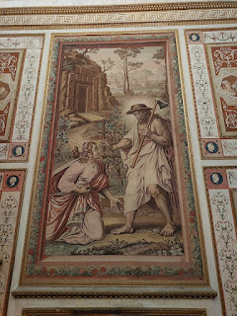

L to R: Caroline, Katie in the back, Me in the front, Andrea, and Rachel

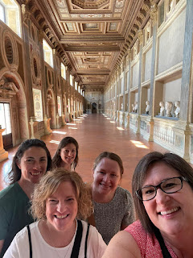

On the way out of the Palace, there was a long hallway of quotes - basically reviews - from famous visitors to this place over the centuries. I liked this one. "This is a wonderful city, it would be worth traveling a thousand miles to see it." (Torquato Tasso, 1586)

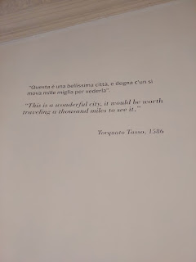

We also passed a room filled with all the special costumes for the movie actors and actresses . . .

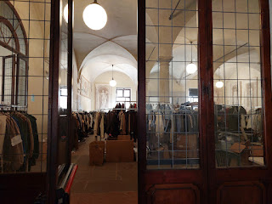

Next door to the main entrance of the Palace is an Archaelogical Museum. I was pretty overloaded already from everything in the Palace, but 3 things jumped out at me.

1) A fascinating explanation of funeral practices in Mantua/Mantova. (click to enlarge photo to read)

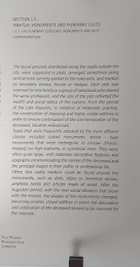

2) Found in a local grave: A necklace and pendant w/ a cameo depicting the Goddess Minerva. (second half of the third century AD)

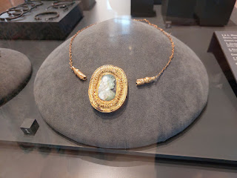

3) A portion of a paved Roman street with cart tracks, uncovered in Mantova. (Circa 1st century AD)

(More info in the photo below - click to enlarge)

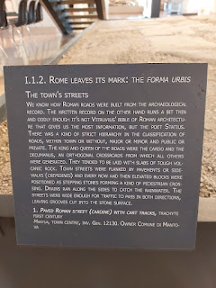

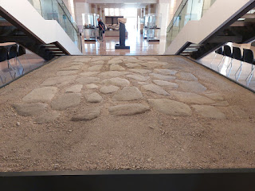

Finally, we made it outside into the fresh air to clear our PACKED heads, ha ha. Maybe you need a break, too. Let's just take a little walk together across the piazza and into old town Mantova.

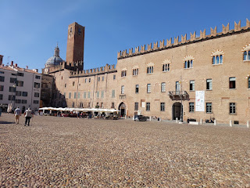

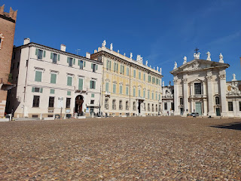

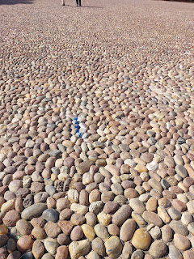

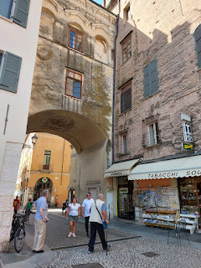

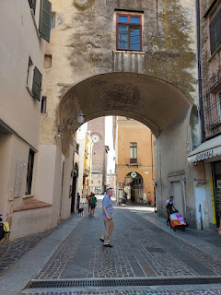

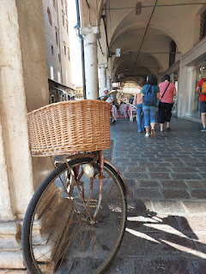

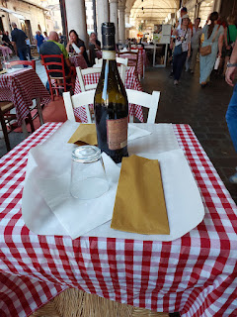

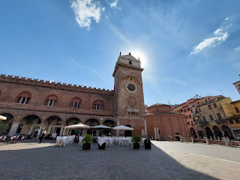

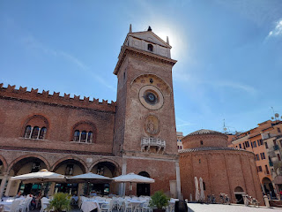

L to R: Rachel, Katie, Andrea, Caroline, and Addie Mae

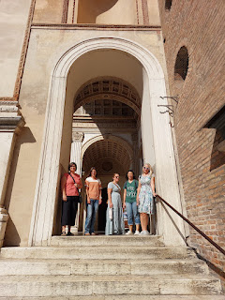

We walked past the cutest little bakery, where we all hit the brakes so we could go inside and inwardly drool over all the beautiful creations.

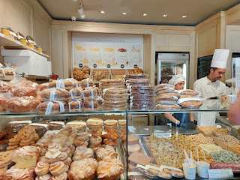

Addie Mae and I were both smitten by the pistachio cakes. She bought a larger one for her family, and I bought a smaller one to bring home. I put mine in the freezer to share with Amber and the girls.

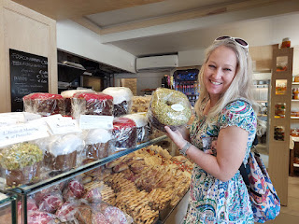

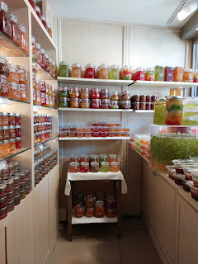

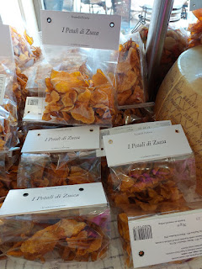

This is the name of the bakery in Mantova.

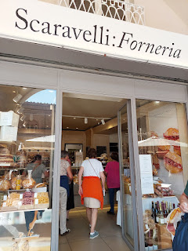

Next door, they had an extension of the bakery where all the work actually gets done.

Video of an artisan preparing some ravioli with a dollop of squash inside each one: (18 seconds)

https://photos.app.goo.gl/Vxg6RDCmBeRrZbpm7

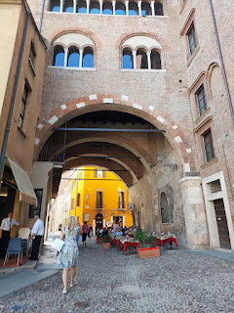

Passing the moat around the Palazzo Ducale on our way back to the car . . .

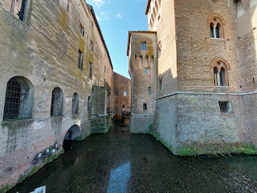

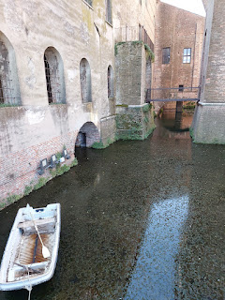

I had bought a cute children's book inside the Palace gift shop and when I got home, I thoroughly enjoyed reading it cover to cover.

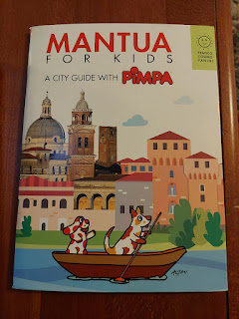

I laughed out loud when I read this little bit . . .

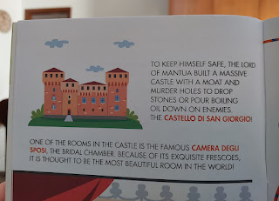

What a day!! What a whirlwind THREE days. I'm so grateful for the opportuity I had to see and do all that I saw and did. I am sure learning a LOT!! If I could go back and start college all over again, I think I would choose to be a history major. :)

Thursday and Friday:

Not much happened, and THANK GOODNESS, ha ha. I washed the bedding, worked on my blog, went to the gym, worked on my blog, did some menu planning, worked on my blog, watched America's Got Talent with Scott, slept, and worked on my blog . . .

Scott also put together a cute nightstand table for the girls' room upstairs while I worked on my blog on Friday.

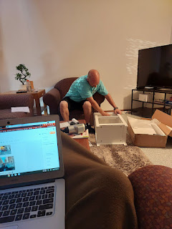

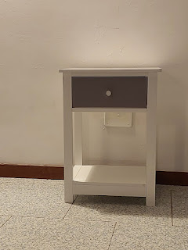

Saturday, September 30th:

Guess who finally arrived!!

Video of our guests pulling into the courtyard: (37 seconds)

https://photos.app.goo.gl/3zFW9wEdS681SBPR7

I had to wait back at home while Scott picked them up in Venice, because they needed enough space in the car to put all their stuff, ha ha. I kept busy by cleaning and getting a few last minute groceries . . . They landed at about 11 a.m., about an hour behind schedule. There was a delay as they tried to leave Toronto the night before.

Turns out, Gwen got the most sleep on the flight over to Italy. Abby slept a little here and there, and Amber got even less. Amber took a nap after they all got settled, and Scott and I entertained the girls while she rested and recovered a bit. We took it easy for the rest of the day: we went on a 2 minute walk to a park that we can see from our kitchen window, we made quesadillas for dinner, we watched a session of general conference, and then we waited for hours (literally) for the girls to settle down to sleep. They were so wound up and hyper that it took until after 10 p.m. for them to quiet down . . .

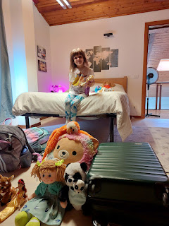

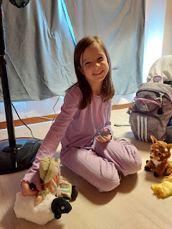

Three cooks in the kitchen . . . Amber, Scott and myself

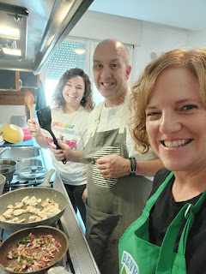

Sunday, October 1st:

We headed up the mountain to visit Asiago after a good, hearty breakfast. Asiago is one hour from our house, but it was also the LAST DAY of the season to visit the Gnome Village. The Gnome Village has a giant playground near the entrance, which ALMOST makes it too hard for the children to stop playing in order to start on the trail into the forest to find the gnomes.

Two very cute gnomes named Gwen and Abby . . .

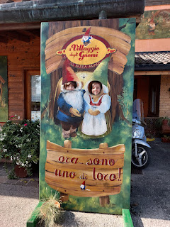

Abby conquered her fear of heights and new things by eventually climbing up this giant "beach ball".

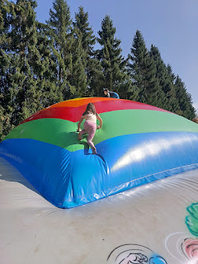

Meanwhile, Gwen made us all dizzy as we watched her on the merry-go-round . . .

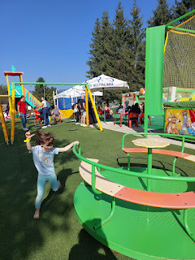

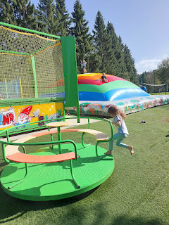

Soon, we were on the trail, keeping our eyes peeled for gnomes, petrified trolls, and forest animals.

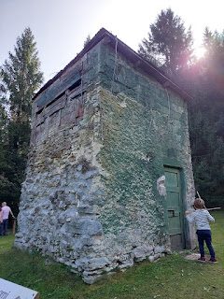

The trail also incorporated various points of skill and adeptness for the children to enjoy . . .

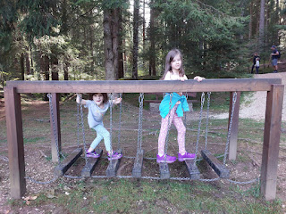

And several off-the-beaten-path choices to sample . . .

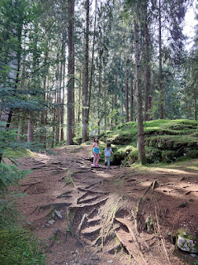

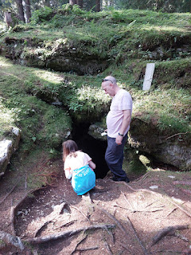

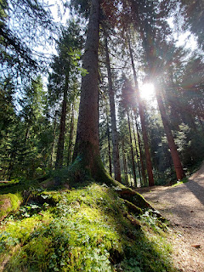

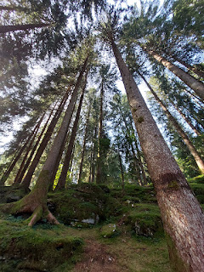

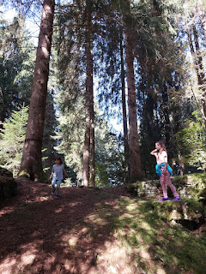

Abby, Gwen, and Amber . . .

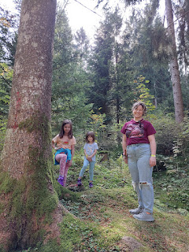

With an upcoming talk in church on the topic of family history, I was fascinated with the theme of "roots and branches" . . .

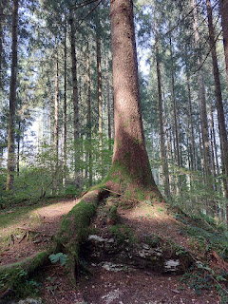

By and by, at last we found the Gnome Village deep in the forest . . .

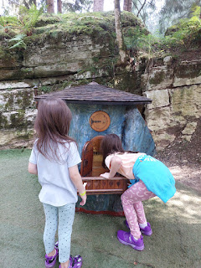

There was a little bit of condensation as we peered into the house, but we really did see gnomes inside!!

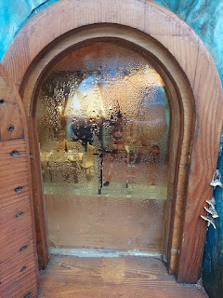

Video of the gnomes preparing dinner inside: (8 seconds)

https://photos.app.goo.gl/uJU6263PfMCRtJhr6

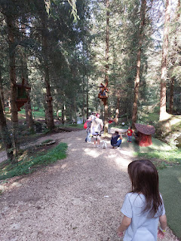

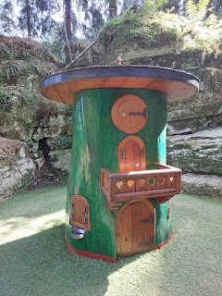

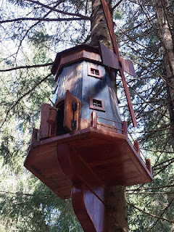

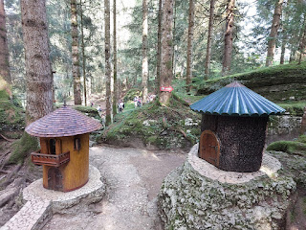

A cross-section of the inside of a gnome house:

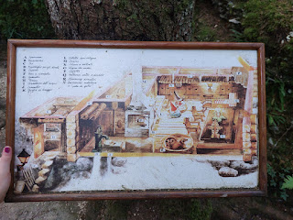

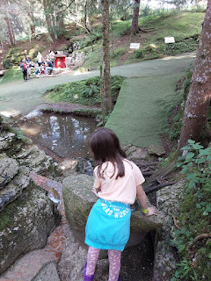

Video of Abby, who found a cool waterfall next to another gnome house: (17 seconds)

https://photos.app.goo.gl/ASfc1QyrgEdm7qrf8

Video of us shimmying through two giant rocks to get to the clearing on the other side: (17 seconds)

https://photos.app.goo.gl/DxSBL3QTcT6BBhFX9

Video of the love and intricate details that went into this village: (32 seconds)

https://photos.app.goo.gl/nPCv6xorZKRwZ5Ur6

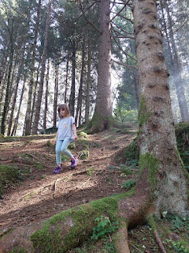

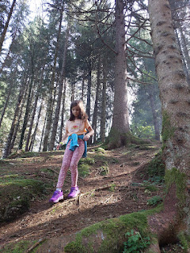

The Gnome Village was a wonderful experience. We could have stayed much longer, but we had a couple  more things to do before needing to be back in Vicenza to prepare for company. So off we went . . .

Next stop in Asiago: Parco Millepini and some pizza from next door. Amber says that the pizza in Italy is A-okay!!

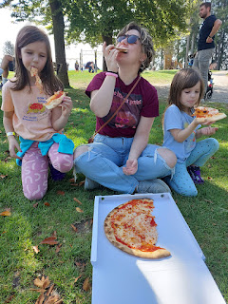

We made one more quick stop at the cheese shop before leaving town. When you're in Asiago, ya gotta get some Asiago cheese!!

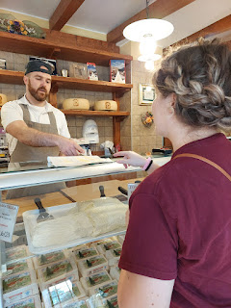

We got home in good time, made all the fixins for a Spud Bar, and had Nell and her husband Mike over to dinner. Nell brought a homemade cake with a mascarpone creamy topping and fresh fruit for a garnish. We watched another session of General Conference after dinner, and even now - at almost 10 p.m., I am waiting for the girls to settle down upstairs and go to sleep . . .

They keep trying to sneak downstairs to grab their shoes so they can go out on the roof, but alas, I have foiled their plans every single time.  Amber is fast asleep, so I am the the last guard on duty . . .

One last thing - - some cute photos of Jack.

